Instruction for Comprehensive Academic
Support System of DUFE (CASS of DUFE)

The Website of Comprehensive Academic Support System of Dongbei University of Finance and Economics：http://202.199.162.105/

Step 1 : Input the account and password.

After you click on the link of website CASS of DUFE, you will see the Login window below.Input your personal account and password, then you can login the system.
You will get your personal account and password from Bob, if you can’t receive them, please contact Bob.
Bob’s Email : boblee567@aliyun.com

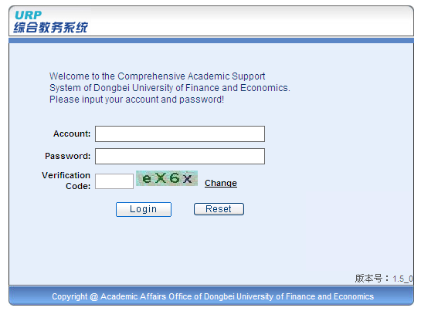
Step 2: Overview
Now you will see the overview window as follows, there are four parts of the page:
1) Personal Info., 2) Enter Grades, 3) Course Info., 4) Teaching Evaluation.

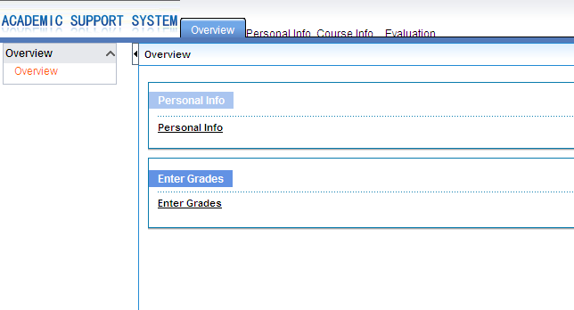

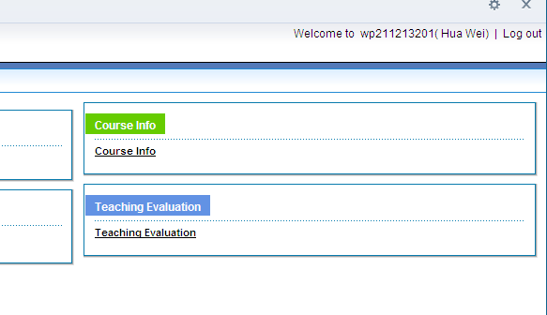

Click on “Personal Info.” button to check your personal information
Click on “Course Info.” button to check your Teaching Schedule. Example as follows:

Personal Info.
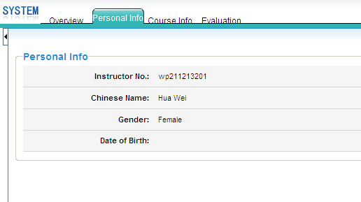

Course Info: Schedule

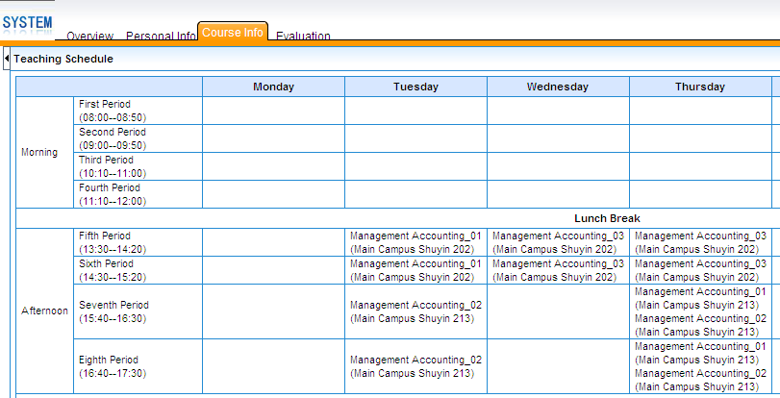

Step 3 : Setup Grading Criteria

1) Go to Enter Grades
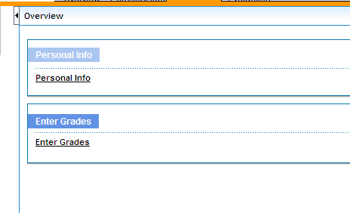

Then you can find the course information you teach this semester, example as follows:

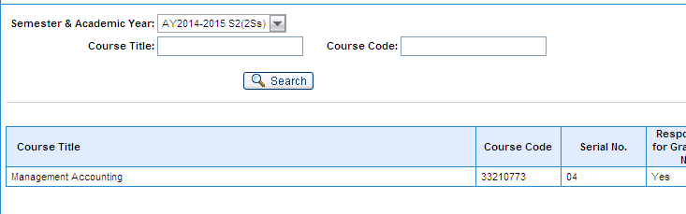

Before you input student grades, you need to set up grading criteria.

- Click on “Input Grading Criteria”.

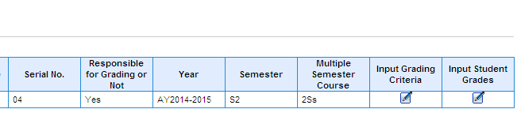

Please input grading criteria as follows:
Overall Grade = Course Grade (Input “1”) + Practice Grade ( Input “0”) + Experiment Grade (Input “0”),

Course Grade = Class Performance ( Input “0”) + Mid-term Exam Grade ( Input “0”) + Final Exam Grade (Input “1”),

and input “0” into the left blanks.

In order to avoid the mistakes while inputting grades, please add up the final grade of each student (i.e. the weighted overall grade including attendance, performance, mid-term and final) in advance so that only the final grade is entered into the system. Of course, you can also set up grading criteria yourself, which is not recommended here.

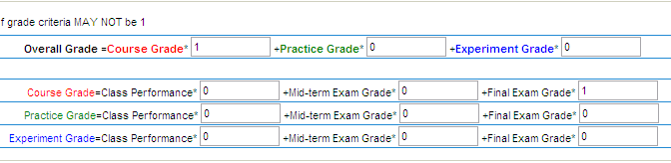

Then, click on “Save” button in the top of right side.

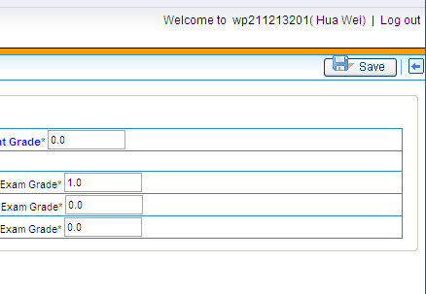
- The system will appear a window informing “grade criteria has been saved successfully”.

Click on “确定” to confirm. After that, you can click on back button next to “Save” button to go back Grading page.

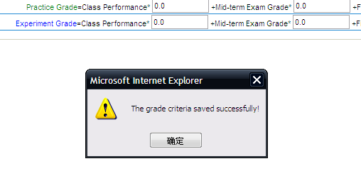

4) Now you can click on “Input Students Grades” and grade for your students.

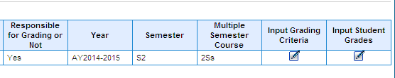

Step 4: Grading

- After step 3 you can see the grading page, example as follows:

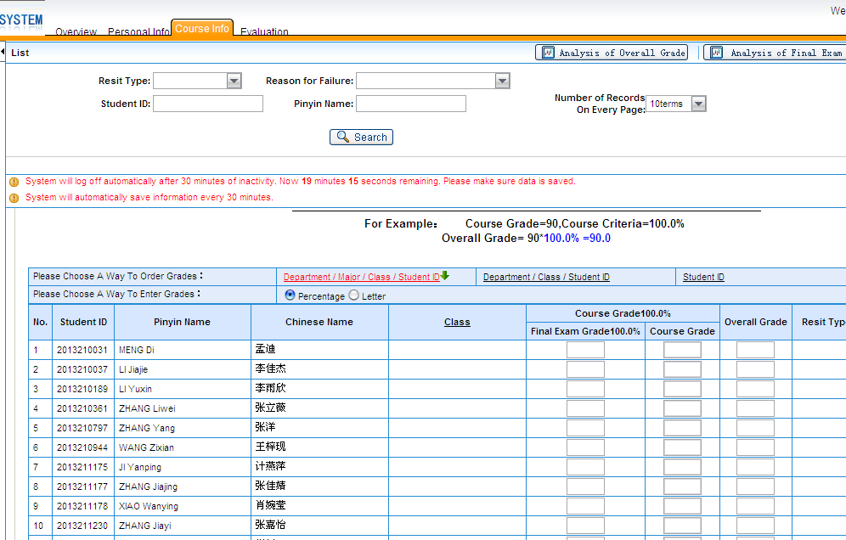

2) Please make sure you have finished setting up the grading criteria before you input the final score of your students . Meanwhile, you need to have calculated out all students’ final mark.

- Now you can fill students’ final mark into the “Final Exam Grade 100.0%”, and please do not fill grades into others blank, for the system will be calculated and fill them automatically after saving. Example as follows:

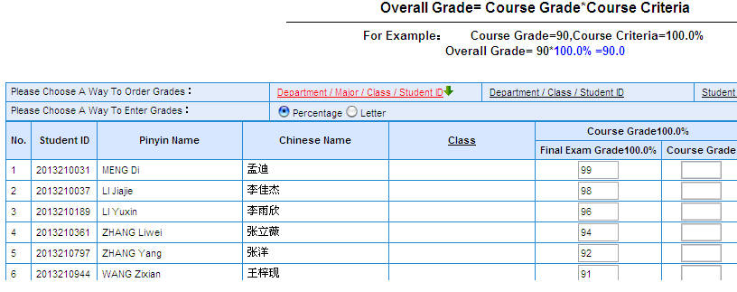

- When you finish grading the class, go to the end of this page and click “Save” to save the grade.

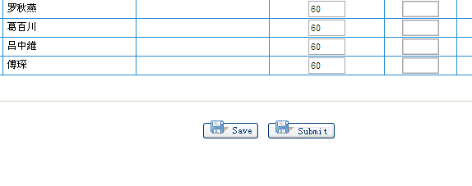

Then you will find other blanks are calculated and filled automatically.

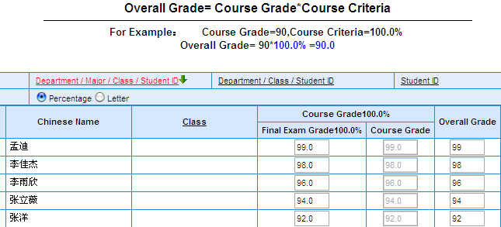

Caution: SAVE means grades are temporarily saved and CAN be modified. SUBMIT means grades are submitted for students to review and CANNOT be modified.

5) After saving the grades, you can check the scores with your personal record in case that there will be a mistake on it.

6) After you check all the grades and make sure they are all correct, do not click on the button of “Submit”, because after the checking from the Board of Examiners, the system will submit the grade automatically unless there is something wrong or unsuitable in it.

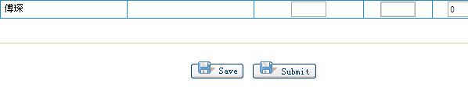

Step 5: Print Transcript and Analysis of Overall Grade

When you finish saving the grades, you need to Print Transcript and Analysis of Overall Grade and write down your own analysis about the exam paper and overall grade.
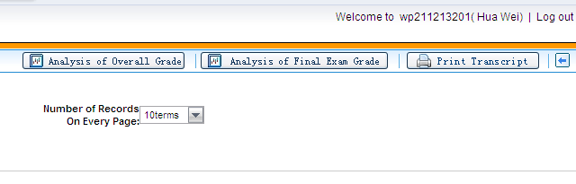
1) Click “Print Transcript” button, then click “Print” to get the paper transcript of grade.
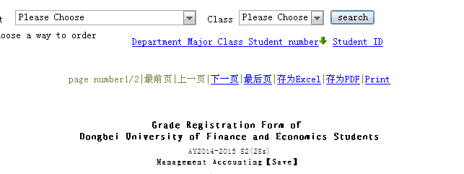
- Sign you name on the required place of Transcript, example as follows:

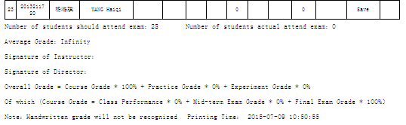
- Also, you need to print the “Analysis of Overall Grade” out and finish the short comments of “Analysis of Exam Paper” and “Analysis of Overall Grade”. Your signature is required, example as follows:

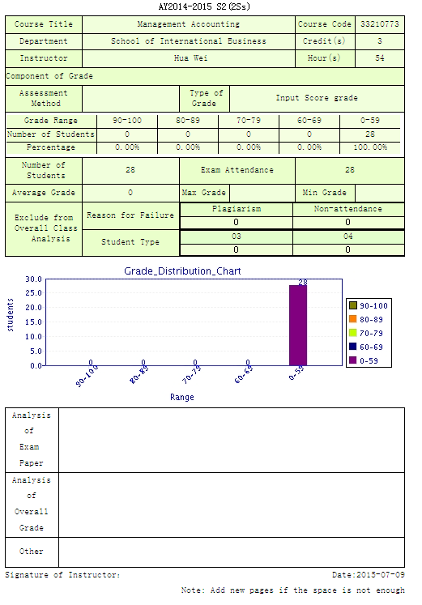
- Now you have completed the grading work of one class. If you have more than one class this semester, you need to go back to Step 3 to choose another class to set up Grading Criteria and input the grade.

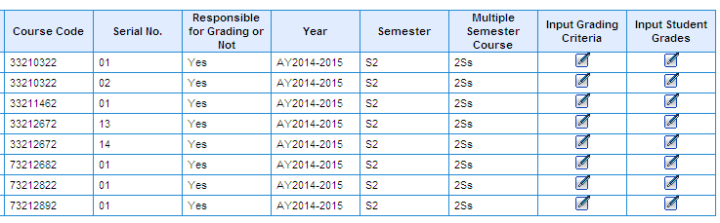

When you finish grading of all your classes,
congratulations, your teaching work in this semester is done.

5) The last thing you need to do is to turn over all your paper materials to Academic Affairs Office of SIB, including Grading Transcript, Analysis of Overall Grade,students' attendance, the grade of homework, quiz, presentation, or mid-term exam etc.

